EXPT NO:7 | IMPLEMENT ADVANCED CHART TYPES USING TABLEAU AND POWER BI
DATE: 14.08.2026

PRE-LAB QUESTIONS (PROVIDE BRIEF ANSWERS TO THE FOLLOWING QUESTIONS)

NAME: ABHISHEK J

ROLL NO.: 24BAD002

What is data integration in the context of Business Intelligence (BI)?
Data integration in Business Intelligence (BI) is the process of combining data from multiple sources into a unified and consistent format for analysis and reporting. Sources may include databases, spreadsheets, cloud applications, and APIs. Integration enables organizations to create a single view of their data, identify patterns, generate accurate insights, and support better business decision-making.

Explain the difference between a join and a data blend in Tableau.
Feature | Join | Data Blend
Meaning | Combines tables using a  common field. | Combines data from separate sources using  a linking field.
Data  Sources | Usually within the same data  source. | Can use different data sources.
Processing | Performed at the database level. | Performed within Tableau during analysis.
Use | Best for detailed row-level  combination. | Useful when sources cannot be directly  joined.

What are relationships and cardinality (e.g., one-to-many, many-to-many) in Power BI's data model?
Concept | Explanation
Relationship | Defines how tables are connected using related columns, allowing data to  work together in reports.
One-to-Many | One record in one table can relate to multiple records in another table.
Many-to-  Many | Multiple records in both tables can be related to each other.
One-to-One | Each record in one table corresponds to one record in another table.

Why is data quality crucial when integrating data from different sources?
Data quality is crucial because inconsistent or incorrect data can produce misleading BI reports and decisions. When integrating different sources, consistent naming conventions, formats, and data types ensure that values are correctly matched and interpreted. High-quality data also reduces duplication, errors, and missing information. Therefore, maintaining data quality improves the accuracy, reliability, and usefulness of integrated business intelligence.

Name two common challenges encountered during data integration.
Two common challenges in data integration are inconsistent data formats and duplicate or missing data. Different sources may store information using different formats, naming conventions, or data types, making combination difficult. Duplicate records can distort analysis, while missing values can reduce accuracy. Proper data cleaning, transformation, validation, and standardization are therefore necessary to achieve reliable integrated data.

IN-LAB EXERCISE:
OBJECTIVE:
To connect, combine, and model data from multiple sources in Tableau and Power BI and create a unified, comprehensive dashboard for holistic analysis.

PROCEDURE:

Data Collection:
  - Import two datasets:
    - Dataset 1: Sales Data (CSV) → Order ID, Order Date, Region, Sales Amount
    - Dataset 2: Regional Sales Targets (Excel) → Region, Sales Target, Target Year

Data Preparation and Transformation:
  - Clean datasets (e.g., standardize "N. America" → "North America"). • Ensure correct data types (numeric for Sales, date for Order Date).
  - Handle missing values appropriately.

Data Integration and Modeling:
  - Tableau: Create a join/relationship on the Region field in the Data Source pane.
  - Power BI: Use the Model view to create a relationship on Region; define cardinality (e.g., many-to-one).

Create Calculated Fields for Comparison:
  - Target Achievement % = (SUM(Sales) / SUM(Sales Target)) * 100
  - Sales vs. Target Variance = SUM(Sales) - SUM(Sales Target)

Design a Comprehensive Dashboard:
  - Combine visuals from both sources.
  - Add KPI cards: Total Sales, Overall Target Achievement %.
  - Use gauge/bullet charts for region-wise target performance.
  - Combined bar chart: Actual Sales vs. Target by Region.
  - Map visualization: Sales vs. Target Variance by region.

Validate Data Integrity:
  - Cross-check joined data for accuracy.
  - Ensure dashboard filters correctly update visuals.

Publishing and Sharing:
  - Tableau: Publish to Tableau Public or Server.
  - Power BI: Publish to Power BI Service and share.

Experiment Datasets:
  - Dataset 1: Retail Sales Data (CSV) → Order ID, Order Date, Region, Sales
  - Dataset 2: Regional Sales Targets (Excel) → Region, Sales Target, Target Year

Tableau
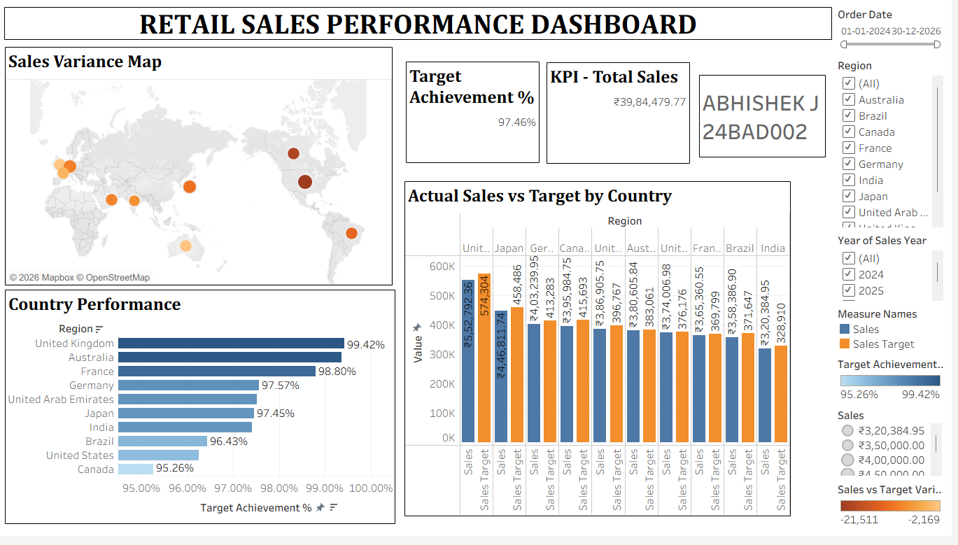

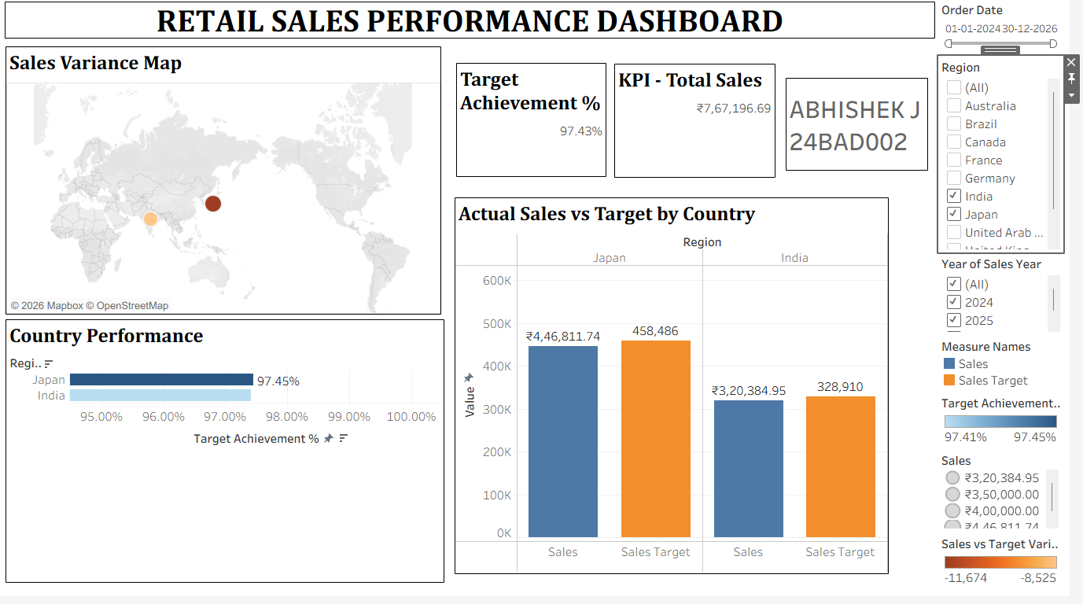

Power BI
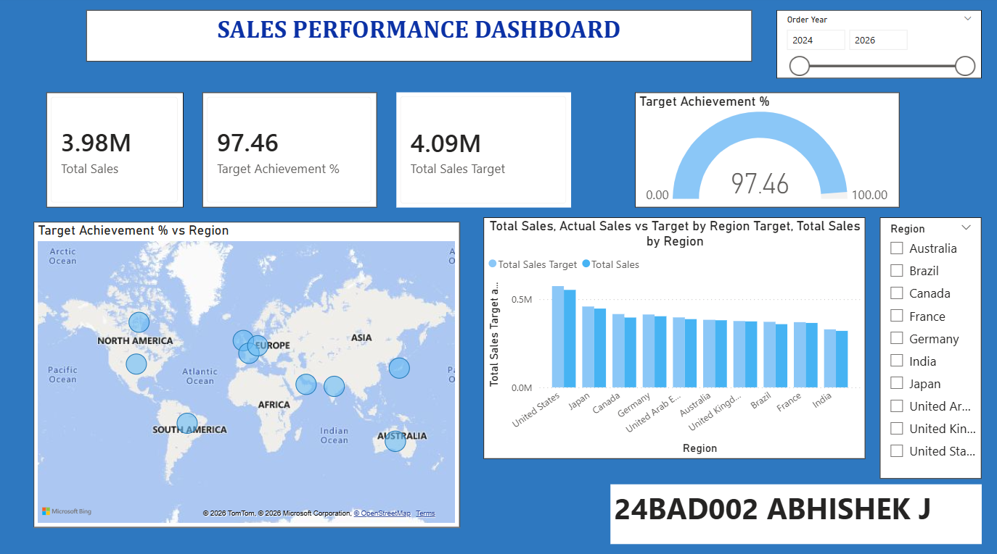

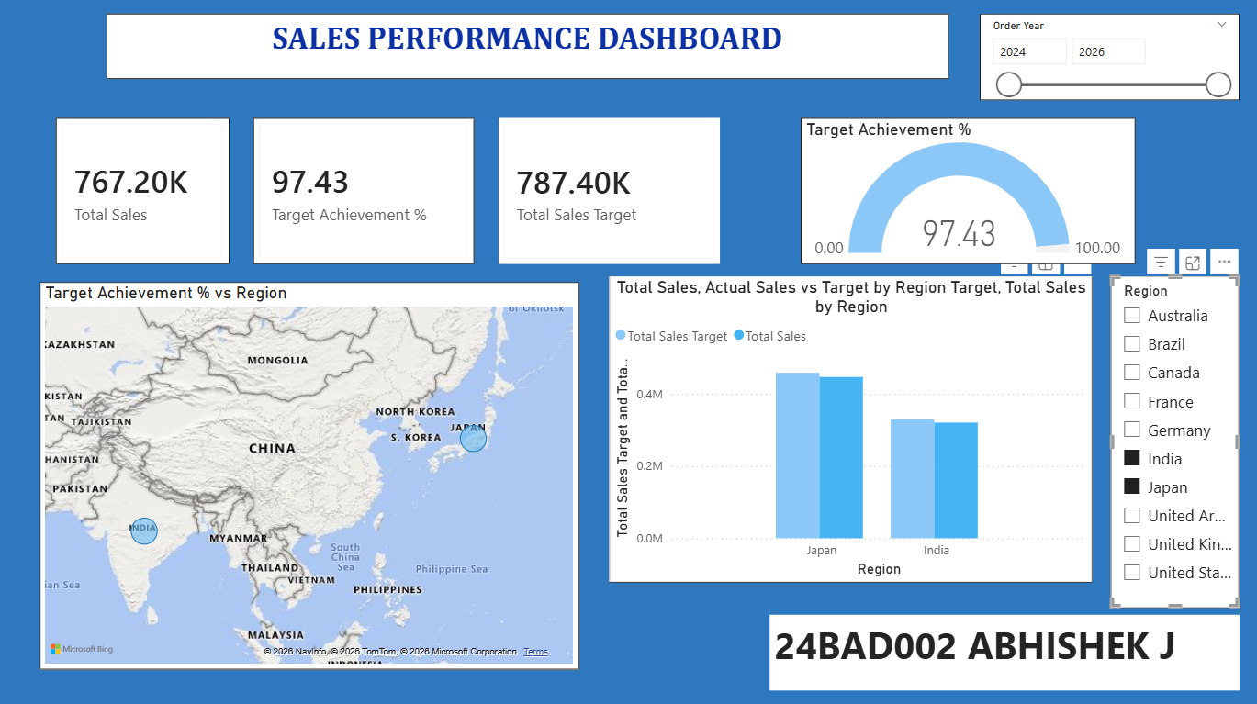

POST-LAB QUESTIONS (PROVIDE BRIEF ANSWERS TO THE FOLLOWING QUESTIONS)

How did integrating the sales targets data provide a more complete analytical picture than using the sales data alone?
Integrating sales targets allowed us to compare actual sales with planned targets for each region and year. Sales data alone shows only how much was sold, while target data shows the expected performance. By combining both, managers can identify regions that exceeded or fell below expectations, measure performance gaps, and understand where improvements are required.

Describe the type of join or relationship you used and why it was appropriate.

Aspect | Explanation
Relationship | Many-to-One relationship
Key | Region
Sales Data | Contains many sales records for each region.
Target Data | Contains regional target records.
Reason | It connects multiple sales records to the corresponding regional target, making regional performance comparison easier.

What challenges did you face regarding data granularity or mismatched keys?
The main challenge was different data granularity. Sales data contains individual orders with specific dates, while target data represents regional targets by year. Therefore, the sales data needs to be aggregated by region and year before comparison. Consistent region names are also important; mismatches such as “North” versus “NORTH” could prevent correct matching and require standardization.

How can variance calculations help a business manager make better decisions?
Variance calculations such as Sales − Target show whether actual performance is above or below expectations. A positive variance indicates that sales exceeded the target, while a negative variance highlights underperformance. Managers can use these results to identify weak regions, allocate resources, adjust sales strategies, set realistic targets, and take corrective actions where performance is below expectations.

What other data source could you integrate to further enrich this analysis?
Marketing campaign data could be integrated with the sales and target datasets. It could include campaign type, advertising spend, campaign dates, and region. This would help determine whether marketing activities influenced sales performance. Managers could identify which campaigns generate higher sales, compare marketing costs with revenue, evaluate regional campaign effectiveness, and improve future marketing budget allocation.

GitHub Link: https://github.com/j-abhishek26/24ADC001-24BAD002/tree/main/Experiment%207

RESULT:

The retail sales and regional targets datasets were successfully connected, cleaned, and integrated in Tableau and Power BI. Relationships between the sources created a unified data model. The dashboard visualized sales performance against targets, enabling variance analysis and providing insights into regional performance not possible with a single data source.

ASSESSMENT

Description | Max Marks | Marks Awarded
Pre Lab Exercise | 5
In Lab Exercise | 10
Post Lab Exercise | 5
Viva | 10
Total | 30
Faculty Signature

